Final Exam CSCI 3250 Spring2021 **Regular Test Time: 75 minutes**

Instructions: 1. You should answer all the questions in the space provided after each question.

2. You should show all of your work step by step to receive full credit.

3. You should email your answers today at the end of test time by replying to this

message and attaching the completed test and adding your First and Last name

on the test.

4. The Subject Line on your reply email should include:

RE: Final Exam Spring 2021 CSCI 3250 First Name Last Name Z#

5. Your Final Exam should be returned in a WORD document.

6. You should design the circuits with the minimum number of gates.

1. Construct a 5-to-32-line decoder with four 3-to-8-line decoders with enable input and one 2-to-4-line decoder built with NAND only.

NOTE: You should only draw the internal circuitry of the 2-4-line decoder with NAND only and draw the other decoders as a block with specified input/output, but without the internal circuitry.

I didn’t have enough time

1. **Using a multiplexer built with NOR only**, design a circuit which its output is one if the majority of its input is one; otherwise, its output should be a zero.

.

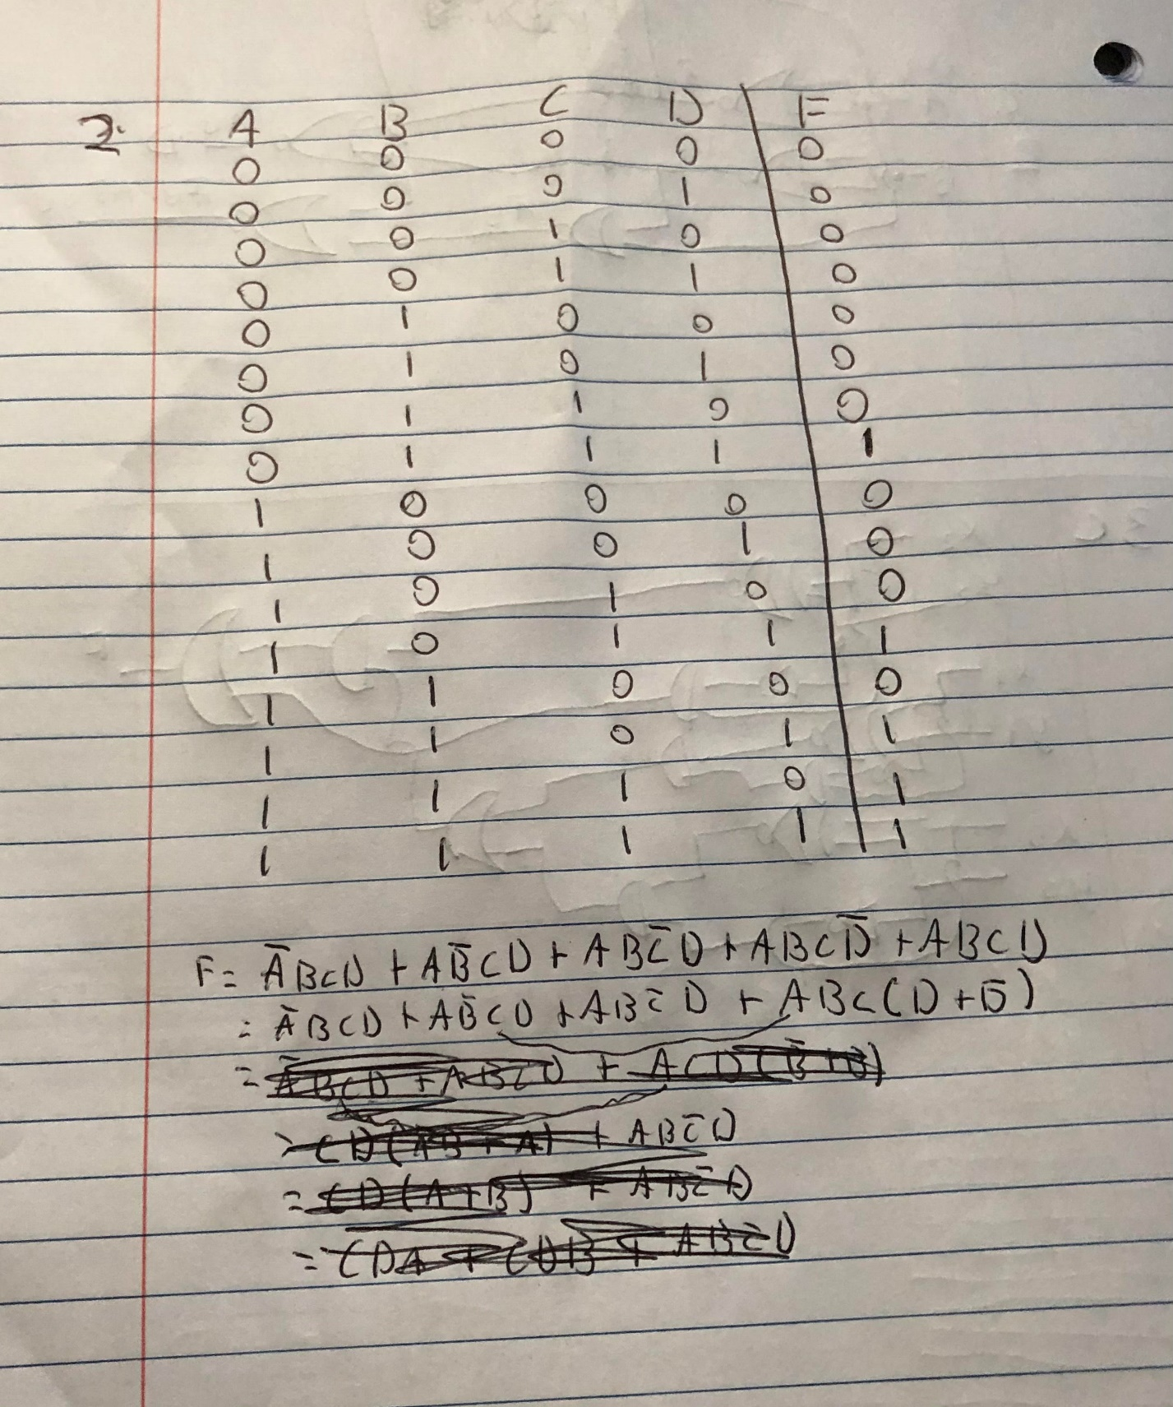

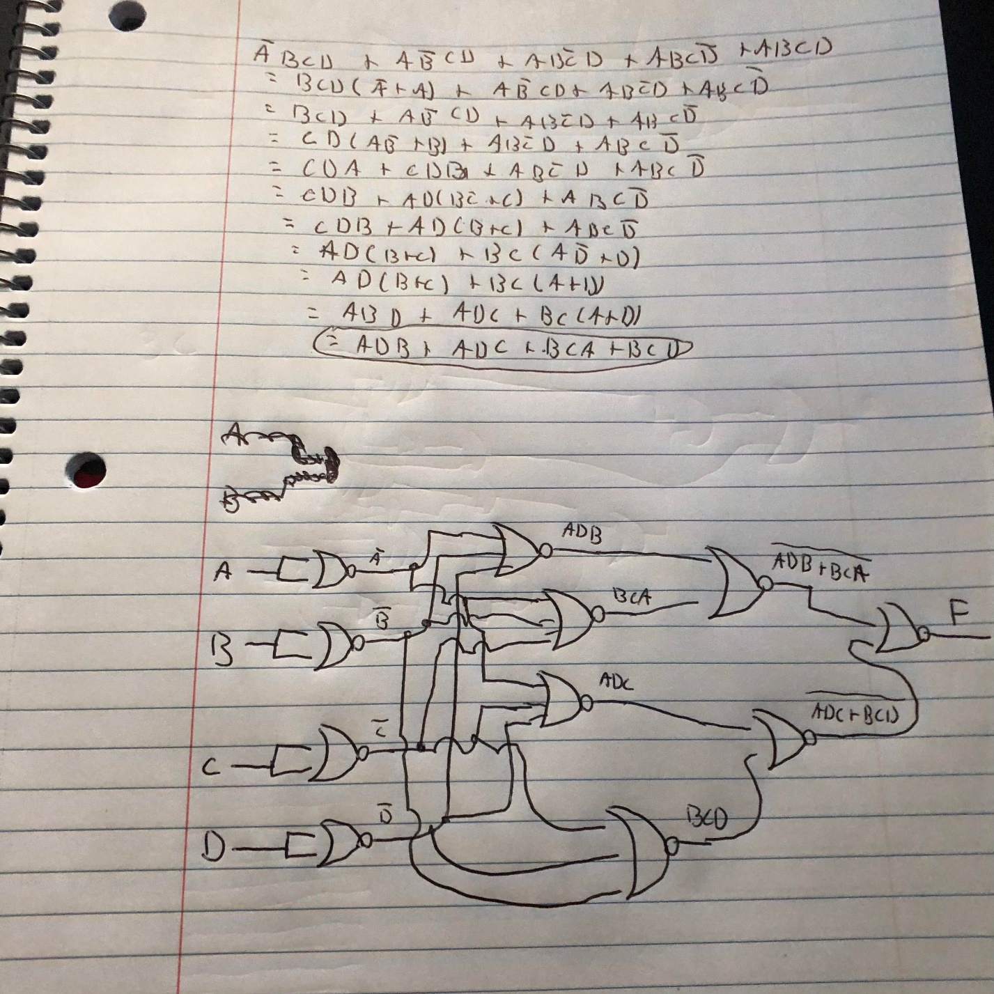

1. Design a comparator to compare X2 X1 X0 >= Y2 Y1 Y0
2. Show your mathematical reasoning (analysis).

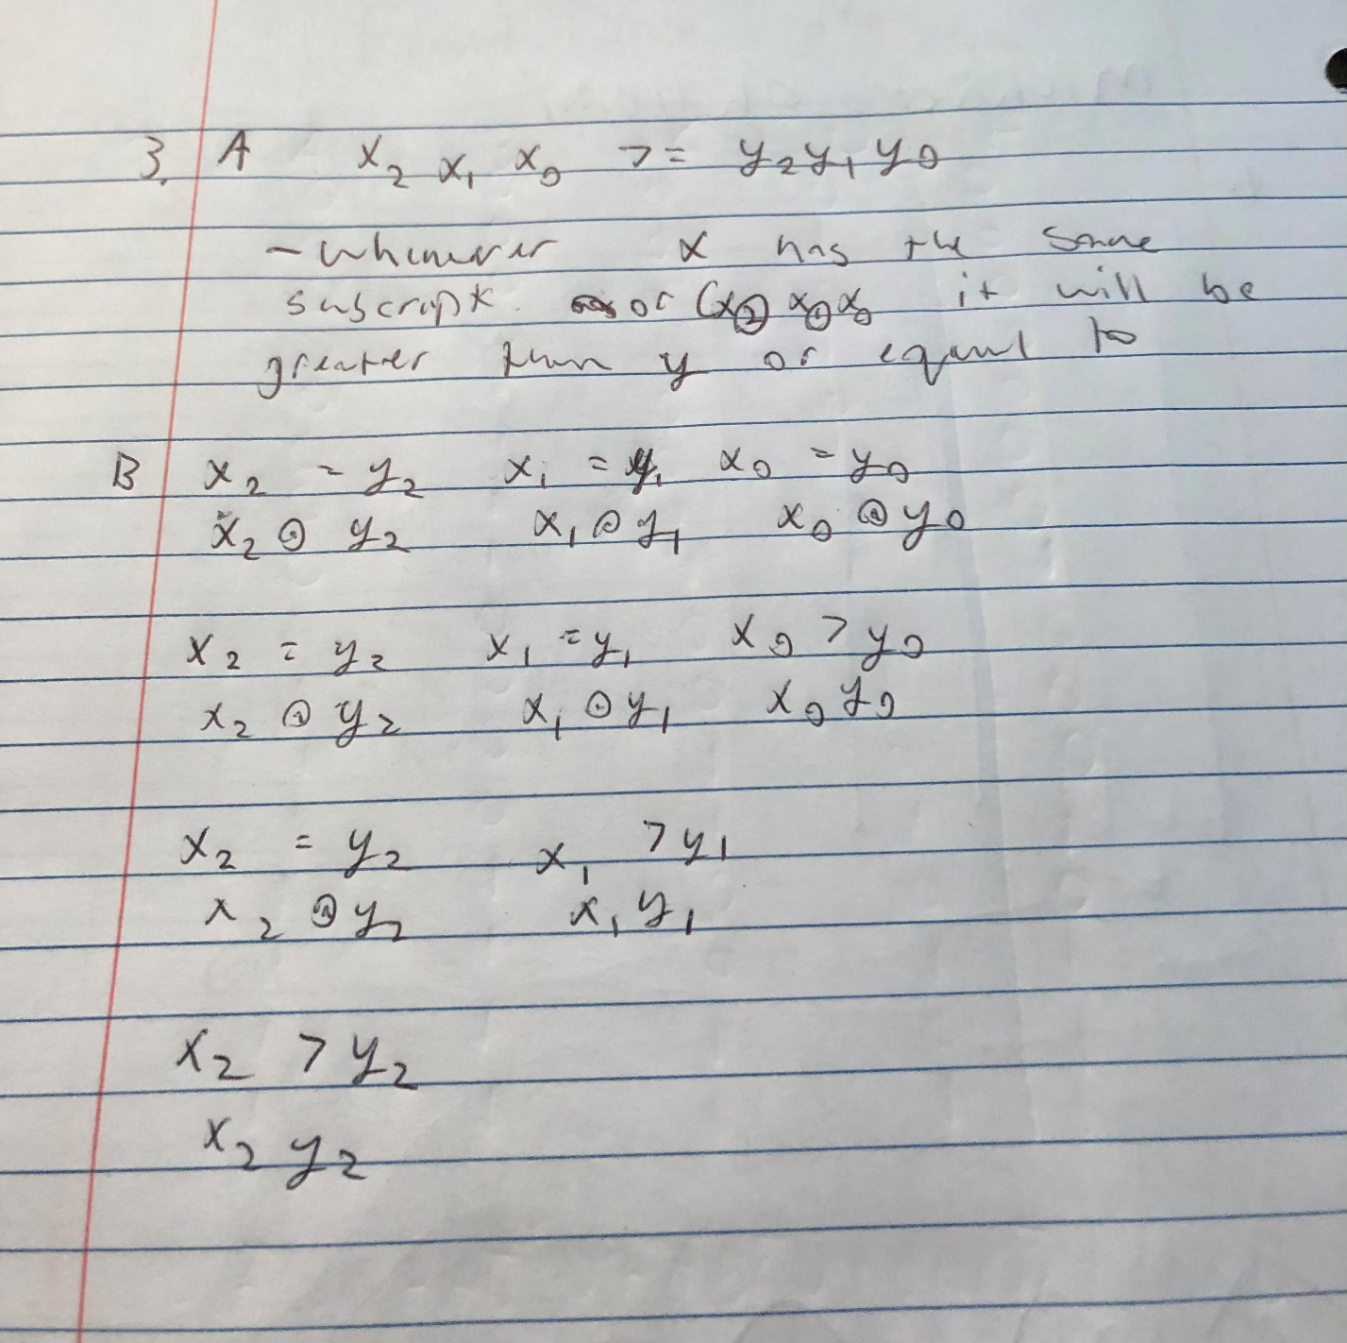

1. Show the logical expression (s).

1. Simplify the logical expression(s) with Boolean algebra and draw the circuit.

NOTE: Your circuit should represent your logical expression and must use Exclusive NOR if necessary.

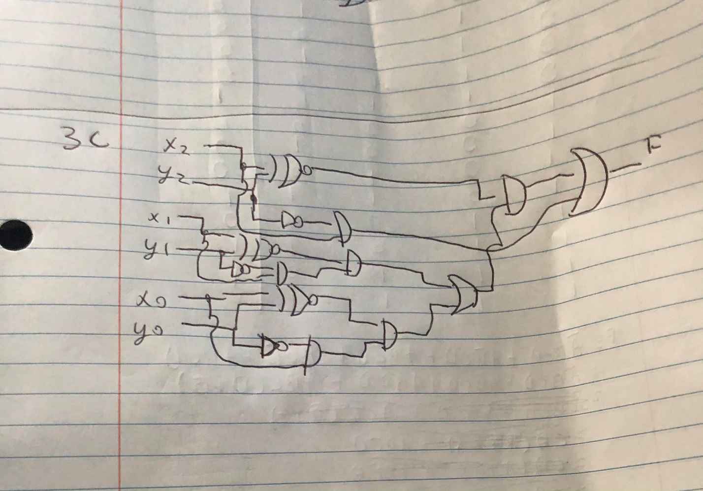

IV A. What does this circuit do?

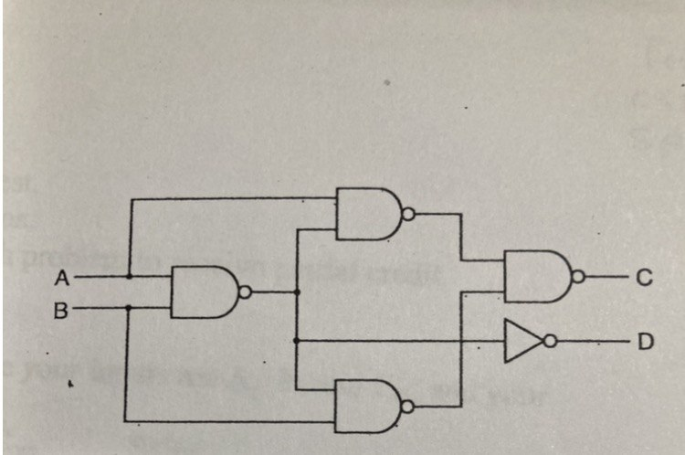

B. Prove your answer to part A by using the Boolean expression which shows that your answer to part A is correct.

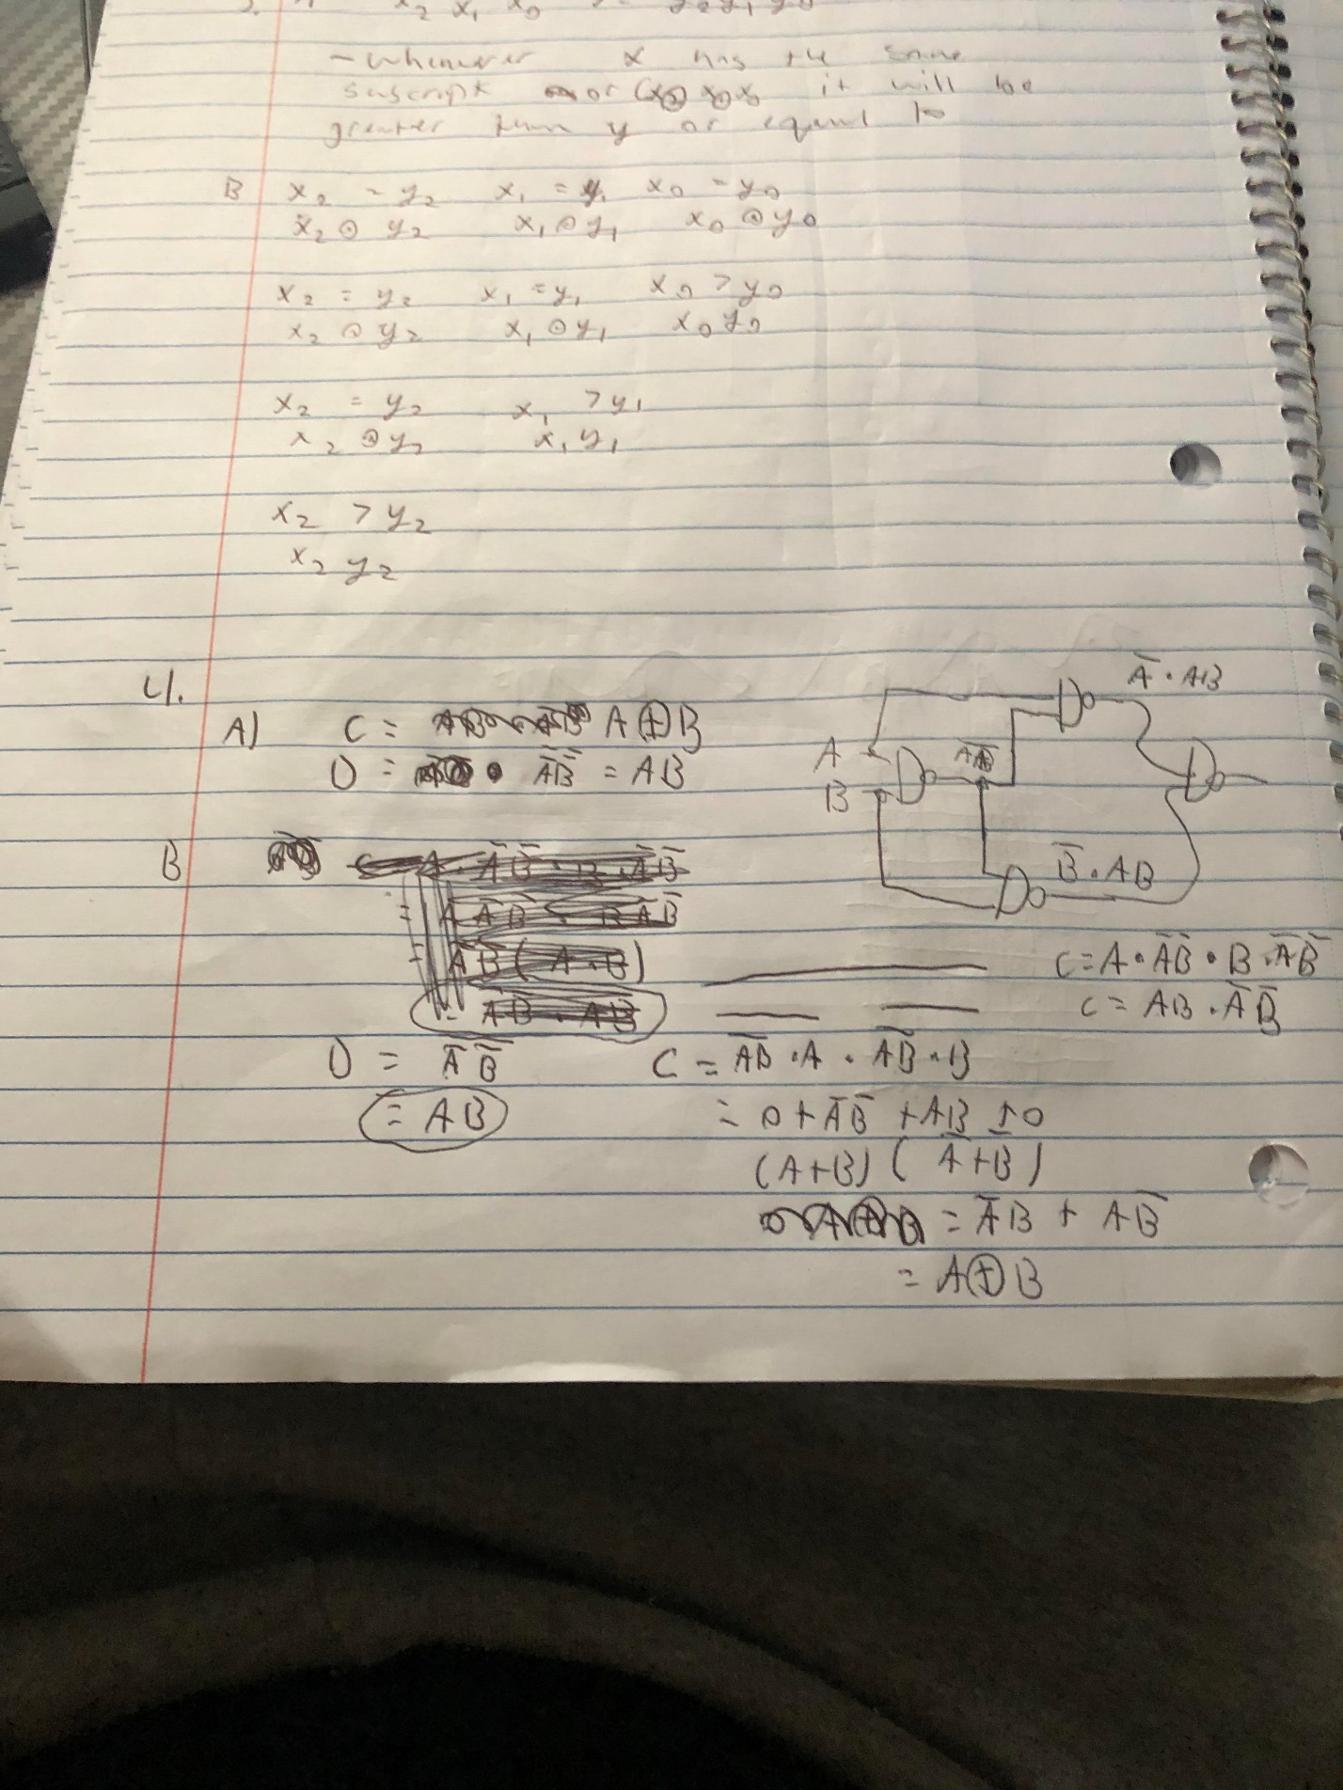

Draw a circuit equivalent to the circuit in part A using NOR only.

